Name: Adilah binti Adi Yasran

Matric: 198989

Web Service Practical

Output for add values

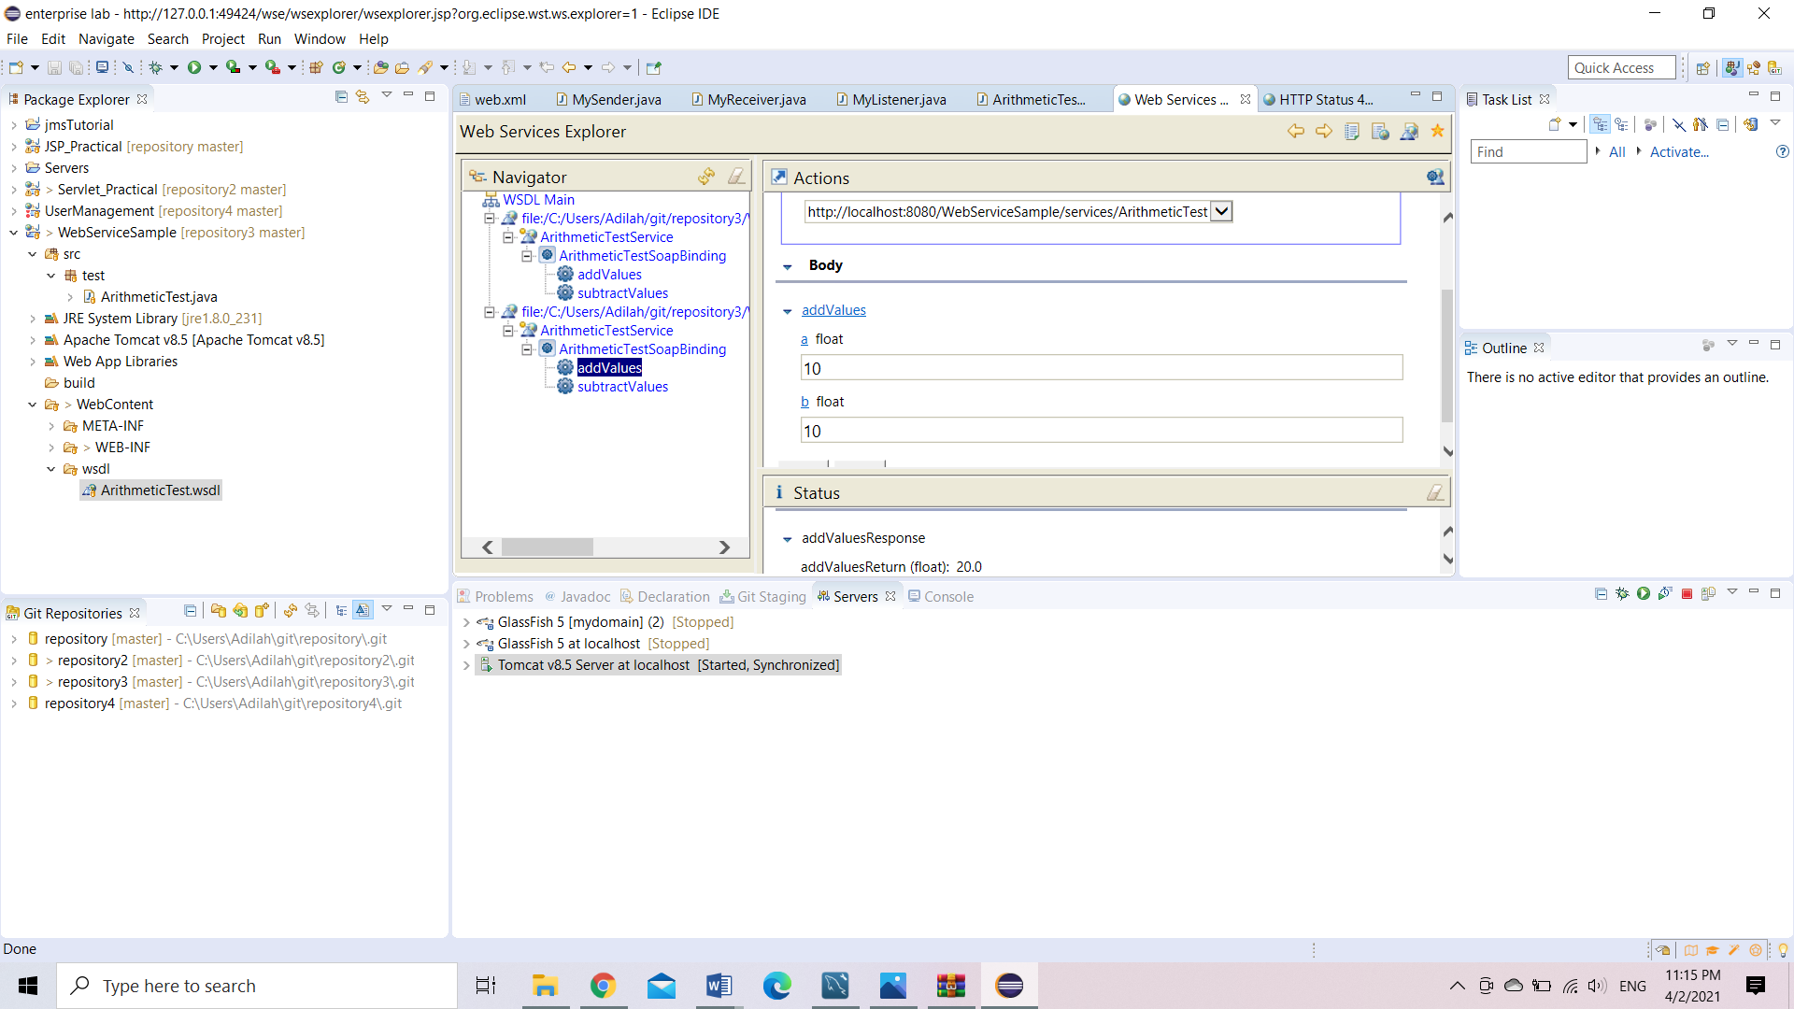

Output for substract values

